**Supporting Information**

**Forest-to-pasture conversion and recovery based on assessment of microbial communities in Eastern Amazon Rainforest**

Alexandre Pedrinho, Lucas William Mendes, Luis Fernando Merloti, Mariley de Cassia da Fonseca, Fabiana de Souza Cannavan, Siu Mui Tsai

Supplementary Tables 1 to 5

Supplementary Figures 1 to 3

1

**SUPPLEMENTARY TABLES**

**Table ST1.** Soil chemical characteristics from 0- to 10 cm topsoil layer in the primary forest, pasture, and secondary forest during the wet and dry season in Belterra - PA, Brazil.

|  |  |  |  |  |  |  |
| --- | --- | --- | --- | --- | --- | --- |
|  | **Primary Forest** | **Pasture** | **Secondary Forest** | **Primary Forest** | **Pasture** | **Secondary Forest** |
|  | **------------------- Wet --------------------** | | | **--------------------- Dry ----------------------** | | |
| C-total (g Kg-1) | 27.68 ±4.67 a | 22.67 ±1.88 a | 23.14 ±3.00 a | 27.32 ±6.95 A | 21.52 ±0.76 A | 21.63 ±4.39 A |
| N-total (g Kg-1) | 2.61 ±0.61 a | 1.71 ±0.30 b | 1.88 ±0.30 b | 2.55 ±0.43 A | 1.52 ±0.43 B | 1.79 ±0.21 B |
| C/N | 10.56 ±1.28 a | 13.27 ±1.89 a | 12.28 ±0.93 a | 10.84 ±2.71 A | 14.16 ±2.40 A | 12.26 ±3.43 A |
| O.M (g Kg-1) | 47.66 ±8.05 a | 39.01 ±3.24 a | 39.88 ±5.16 a | 47.11 ±11.96 A | 37.6 ±2.07 A | 37.21 ±7.56 A |
| pH | 3.60 ±0.20 b | 4.66 ±0.16 a | 3.86 ±0.18 b | 3.32 ±0.19 B | 4.56 ±0.35 A | 3.72 ±0.19 B |
| PO42- (mg Kg-1) | 6.00 ±0.71 a | 5.81 ±1.48 a | 5.43 ±0.55 a | 7.41 ±1.67 A | 8.01 ±3.16 A | 6.83 ±1.30 A |
| K+ (mmolc Kg-1) | 0.56 ±0.17 a | 0.44 ±0.13 ab | 0.30 ±0.10 b | 0.88 ±0.19 A | 1.46 ±1.13 A | 0.60 ±0.12 A |
| Ca2+ (mmolc Kg-1) | 5.84 ±5.16 b | 13.61 ±3.36 a | 3.20 ±0.44 b | 6.02 ±5.66 B | 24.05 ±9.54 A | 3.21 ±0.45 B |
| Mg2+ (mmolc Kg-1) | 4.24 ± 1.41 b | 8.45 ±2.70 a | 4.21 ±1.22 b | 3.21 ±1.22 B | 9.27 ±3.90 A | 4.24 ±2.39 B |
| Al3+ (mmolc Kg-1) | 21.10± 5.29 a | 2.23 ±1.73 c | 14.44 ±2.30 b | 10.65 ±1.67 A | 1.64 ±0.89 B | 9.43 ±2.61 A |
| H+Al (mmolc Kg-1) | 137.66 ±32.50 a | 42.89 ±9.12 c | 83.61 ±15.83 b | 94.22 ±24.93 A | 30.63 ±6.06 C | 66.81 ±6.26 B |
| EB (mmolc Kg-1) | 10.36 ±6.43 b | 22.44 ±5.76 a | 6.10 ±1.48 b | 9.48 ±7.12 B | 34.66 ±13.53 A | 7.40 ±2.40 B |
| CEC (mmolc Kg-1) | 147.96 ±29.60 a | 65.24 ±6.61 b | 89.70 ±16.37 b | 103.68 ±24.93 A | 65.26 ±8.39 B | 74.40 ±7.28 B |
| V (%) | 7.41 ±5.94 b | 35.10 ±9.27 a | 6.82 ±1.79 b | 9.22 ±6.30 B | 51.81 ±14.41 A | 10.02 ±2.91 B |
| m (%) | 67.61 ±17.78 a | 9.43 ±9.68 b | 70.42 ±6.77 a | 54.44 ±15.19 A | 5.47 ±4.56 B | 56.02 ±13.76 A |

Mean values and standard deviations are shown (n = 4). The different lowercase letters indicate significant differences among the areas during the wet season (P < 0.05). The different uppercase letters indicate significant differences among the areas during the dry season (P < 0.05).

## **Table ST2.** Soil physical characteristics from 0- to 10-cm topsoil layer in the primary forest, pasture, and secondary forest during the wet and dry season in Belterra - PA, Brazil.

|  |  |  |  |  |  |  |
| --- | --- | --- | --- | --- | --- | --- |
|  | **Primary Forest** | **Pasture** | **Secondary Forest** | **Primary Forest** | **Pasture** | **Secondary Forest** |
|  | **-------------------- Wet ---------------------** | | | **-------------------- Dry ----------------------** | | |
| Macropres (cm-3 cm-3) | 0.45 ±0.02 a | 0.29 ±0.03 b | 0.29 ±0.05 b | 0.45 ±0.02 A | 0.30 ±0.04 B | 0.29 ±0.05 B |
| Micropores (cm-3 cm-3) | 0.19 ±0.06 a | 0.21 ±0.07 a | 0.27 ±0.06 a | 0.21 ±0.06 A | 0.15 ±0.09 A | 0.27 ±0.06 A |
| Total pores (cm-3 cm-3) | 0.64 ±0.05 a | 0.50 ±0.04 b | 0.56 ±0.04 b | 0.67 ±0.03 A | 0.45 ±0.05 C | 0.56 ±0.04 B |
| Water Holding Capacity (cm-3 cm-3) | 0.43 ±0.04 a | 0.25 ±0.01 b | 0.25 ±0.03 b | 0.42 ±0.03 A | 0.24 ±0.04 B | 0.25 ±0.05 B |
| Soil density (g cm-3) | 0.81 ±0.11 c | 1.33 ±0.11 a | 1.09 ±0.01 b | 0.80 ±0.09 C | 1.34 ±0.12 A | 1.10 ±0.10 B |
| Sand (g Kg-1) | 36.20 ±10.06 c | 462.00 ±34.14  b | 529.60 ±50.83 a | 29.60 ±7.54 B | 461.81 ±34.00  B | 541.59 ±10.16 A |
| Silt (g Kg-1) | 145.20 ±43.04 a | 67.20 ±19.65 b | 96.80 ±8.58 b | 165.00 ±45.53 A | 67.15 ±19.65  B | 94.80 ±17.68 B |
| Clay (g Kg-1) | 818.60 ±37.23 a | 470.80 ±3.36 b | 371.60 ±0.44 b | 805.40 ±5.66 A | 471.04 ±9.54  B | 363.61 ±0.45 B |

Mean values and standard deviations are shown (n = 4). The different lowercase letters indicate significant differences among the areas during the wet season (P < 0.05). The different uppercase letters indicate significant differences among the areas during the dry season (P < 0.05).

## **Table ST3**. Number of sequencing reads, base pairs, GC content, predicted protein, identified protein, and functional categories on MG-RAST pipeline.

|  |  |  |  |  |  |  |  |  |  |  |  |
| --- | --- | --- | --- | --- | --- | --- | --- | --- | --- | --- | --- |
| MG-RAST ID | AREA | SEASON | Number of sequences | Average size (bp) | GC  content (%) | Number of sequences | Average size (bp) | GC  content (%) | Protein prediction | Identified protein | Functional categories |
|  |  |  | Before quality control | | | After quality control | | |  |  |  |
| 4775027.3 | FP | wet | 10,045,202 | 108 ± 22 | 62 ± 9 | 9,768,244 | 107 ± 22 | 62 ± 9 | 8,243,120 | 1,687,084 | 1,290,863 |
| 4775025.3 | FP | wet | 13,419,185 | 107 ± 21 | 62 ± 9 | 13,067,587 | 106 ± 21 | 62 ± 9 | 10,807,476 | 2,161,858 | 1,642,508 |
| 4775026.3 | FP | wet | 13,078,589 | 107 ± 21 | 63 ± 9 | 12,728,855 | 106 ± 21 | 63 ± 9 | 10,536,194 | 2,193,416 | 1,666,934 |
| 4775024.3 | FP | wet | 12,157,568 | 107 ± 20 | 62 ± 9 | 11,784,611 | 106 ± 20 | 62 ± 9 | 9,837,494 | 1,940,207 | 1,475,495 |
| 4775293.3 | SF | wet | 14,536,862 | 107 ± 21 | 62 ± 8 | 14,130,588 | 106 ± 21 | 62 ± 8 | 12,131,496 | 2,609,605 | 2,005,574 |
| 4775298.3 | SF | wet | 15,092,767 | 107 ± 21 | 62 ± 9 | 14,702,771 | 106 ± 21 | 62 ± 9 | 12,840,620 | 2,967,419 | 2,284,686 |
| 4775292.3 | SF | wet | 14,139,119 | 106 ± 20 | 62 ± 8 | 13,732,282 | 105 ± 20 | 61 ± 8 | 11,296,866 | 2,253,894 | 1,714,086 |
| 4775300.3 | SF | wet | 15,318,094 | 106 ± 20 | 61 ± 8 | 14,933,627 | 106 ± 20 | 61 ± 8 | 12,938,749 | 2,744,833 | 2,105,323 |
| 4775294.3 | PA | wet | 16,874,804 | 113 ± 27 | 66 ± 9 | 16,444,038 | 112 ± 27 | 66 ± 9 | 14,502,107 | 3,712,876 | 2,854,986 |
| 4775428.3 | PA | wet | 12,718,939 | 107 ± 21 | 65 ± 9 | 12,427,948 | 107 ± 21 | 65 ± 9 | 10,867,979 | 2,565,765 | 1,963,154 |
| 4775405.3 | PA | wet | 14,607,852 | 107 ± 21 | 64 ± 9 | 14,338,333 | 106 ± 21 | 64 ± 9 | 12,918,199 | 3,060,708 | 2,352,603 |
| 4775414.3 | PA | wet | 16,093,495 | 109 ± 23 | 65 ± 9 | 15,786,540 | 109 ± 24 | 65 ± 9 | 14,295,883 | 3,468,067 | 2,671,816 |
| 4775424.3 | FP | dry | 15,622,101 | 108 ± 22 | 62 ± 9 | 15,302,218 | 108 ± 22 | 62 ± 9 | 13,246,604 | 2,864,484 | 2,213,723 |
| 4775430.3 | FP | dry | 16,253,338 | 110 ± 25 | 61 ± 9 | 15,840,131 | 110 ± 25 | 62 ± 9 | 13,515,653 | 2,866,049 | 2,191,857 |
| 4775419.3 | FP | dry | 14,225,828 | 106 ± 20 | 62 ± 9 | 13,874,889 | 106 ± 20 | 62 ± 9 | 11,348,036 | 2,249,154 | 1,707,640 |
| 4775969.3 | FP | dry | 16,225,105 | 106 ± 20 | 62 ± 9 | 15,767,589 | 106 ± 20 | 62 ± 9 | 13,572,137 | 2,837,047 | 2,010,380 |
| 4775407.3 | SF | dry | 14,292,339 | 108 ± 22 | 62 ± 9 | 13,993,610 | 108 ± 22 | 62 ± 9 | 12,291,049 | 2,784,356 | 2,140,031 |
| 4775406.3 | SF | dry | 10,792,277 | 107 ± 21 | 62 ± 8 | 10,557,380 | 107 ± 21 | 62 ± 8 | 9,049,720 | 2,050,769 | 1,548,703 |
| 4775400.3 | SF | dry | 13,107,613 | 109 ± 23 | 61 ± 8 | 12,817,213 | 108 ± 23 | 61 ± 8 | 10,554,126 | 2,158,871 | 1,638,418 |
| 4775410.3 | SF | dry | 15,374,050 | 111 ± 26 | 61 ± 8 | 15,028,400 | 111 ± 26 | 61 ± 8 | 13,069,562 | 3,024,548 | 2,335,386 |
| 4775411.3 | PA | dry | 13,253,481 | 112 ± 26 | 65 ± 9 | 12,907,785 | 111 ± 26 | 65 ± 9 | 10,910,752 | 2,678,254 | 2,056,317 |
| 4775409.3 | PA | dry | 16,059,057 | 113 ± 28 | 65 ± 9 | 15,675,558 | 113 ± 29 | 65 ± 9 | 13,799,009 | 3,491,166 | 2,698,052 |
| 4775402.3 | PA | dry | 14,462,397 | 113 ± 28 | 64 ± 9 | 14,123,812 | 113 ± 28 | 64 ± 9 | 12,464,959 | 3,122,565 | 2,371,977 |
| 4775398.3 | PA | dry | 14,166,512 | 110 ± 25 | 64 ± 9 | 13,857,926 | 110 ± 25 | 64 ± 9 | 12,458,871 | 3,001,047 | 2,312,851 |

**Table ST4.** Topological characteristics of the networks along the different land-use.

|  |  |  |  |
| --- | --- | --- | --- |
| **Network properties** | **Primary Forest** | **Pasture** | **Secondary Forest** |
| Number of nodesa | 259 | 429 | 275 |
| Number of edgesb | 3110 | 7025 | 2136 |
| Positive edgesc | 2117 | 4996 | 1616 |
| Negative edgesd | 993 | 2029 | 520 |
| Modularitye | 1.17 | 1.11 | 0.82 |
| Number of communitiesf | 20 | 30 | 26 |
| Network diameterg | 13 | 12 | 11 |
| Average path lengthh | 3.88 | 3.27 | 3.76 |
| Average degreei | 24.01 | 32.75 | 15.53 |
| Average clustering coefficientj | 0.71 | 0.63 | 0.62 |

aMicrobial taxon (at genus level) with at least one significant (P < 0.01) and strong (SparCC > 0.9 or < - 0.9) correlation;

bNumber of connections/correlations obtained by SparCC analysis;

cSparCC positive correlation (> 0.9 with P < 0.01);

dSparCC negative correlation (< -0.9 with P < 0.01);

eThe capability of the nodes to form highly connected communities, that is, a structure with high density of between nodes connections (inferred by Gephi);

fA community is defined as a group of nodes densely connected internally (Gephi);

gThe longest distance between nodes in the network, measured in number of edges (Gephi);

hAverage network distance between all pair of nodes or the average length off all edges in the network (Gephi);

iThe average number of connections per node in the network, that is, the node connectivity (Gephi);

jHow nodes are embedded in their neighborhood and the degree to which they tend to cluster together (Gephi).

## 5

**Supplementary Table 5.** Top ten genera with more betweeness centrality and number of correlations (that is, degree) for each treatment.

**Betweeness Centrality Degree Phylum Genus Value Phylum Genus Value**

|  |  |  |  |  |  |  |  |
| --- | --- | --- | --- | --- | --- | --- | --- |
| **Primary Forest** | Actinobacteria | *Rubrobacter* | 4944 |  | Actinobacteria | *Intrasporangium* | 84 |
| Chloroflexi | *Thermomicrobium* | 4511 |  | Actinobacteria | *Stackebrandtia* | 82 |
|  | DeinococcusThermus | *Deinococcus* | 4096 |  | Proteobacteria | *Nitrosococcus* | 81 |
|  | Proteobacteria | *Cupriavidus* | 3542 |  | Proteobacteria | *Ralstonia* | 80 |
|  | Proteobacteria | *Rhodomicrobium* | 3141 |  | Actinobacteria | *Nocardioides* | 80 |
|  | Proteobacteria | *Sinorhizobium* | 2359 |  | Actinobacteria | *Catenulispora* | 79 |
|  | Proteobacteria | *Variovorax* | 2147 |  | Actinobacteria | *Geodermatophilus* | 78 |
|  | Proteobacteria | *Dechloromonas* | 2079 |  | Actinobacteria | *Saccharopolyspora* | 78 |
|  | Proteobacteria | *Methylococcus* | 2030 |  | Actinobacteria | *Amycolatopsis* | 77 |
|  | Chloroflexi | *Ktedonobacter* | 1863 |  | Actinobacteria | *Saccharomonospora* | 77 |
|  |  |  |  |  |  |  |  |
| **Pasture** | Actinobacteria | *Mobiluncus* | 5131 |  | Proteobacteria | *Legionella* | 128 |
|  | Chloroflexi | *Ktedonobacter* | 4835 |  | Proteobacteria | *Xanthomonas* | 127 |
|  | Proteobacteria | *Acidithiobacillus* | 3685 |  | Proteobacteria | *Pseudomonas* | 122 |
|  | Proteobacteria | *Desulfarculus* | 3286 |  | Firmicutes | *Thermincola* | 122 |
|  | Actinobacteria | *Frankia* | 2967 |  | Proteobacteria | *Cupriavidus* | 121 |
|  | Proteobacteria | *Cupriavidus* | 2630 |  | Proteobacteria | *Pseudoalteromonas* | 118 |
|  | Actinobacteria | *Brachybacterium* | 2521 |  | Proteobacteria | *Xylella* | 113 |
|  | Proteobacteria | *Polaromonas* | 2387 |  | Proteobacteria | *Burkholderia* | 113 |
|  | Proteobacteria | *Bordetella* | 2311 |  | Proteobacteria | *Ralstonia* | 111 |
|  | Actinobacteria | *Catenulispora* | 2122 |  | Proteobacteria | *Enterobacter* | 107 |
|  |  |  |  |  |  |  |  |
| **Secondary Forest** | Proteobacteria | *Stigmatella* | 4814 |  | Proteobacteria | *Alkalilimnicola* | 63 |
| Cyanobacteria | *Anabaena* | 3342 |  | Proteobacteria | *Thiobacillus* | 63 |
|  | Proteobacteria | *Myxococcus* | 3019 |  | Proteobacteria | *Methylococcus* | 62 |
|  | Actinobacteria | *Amycolatopsis* | 3000 |  | Proteobacteria | *Thioalkalivibrio* | 62 |
|  | Proteobacteria | *Novosphingobium* | 2141 |  | Proteobacteria | *Sideroxydans* | 58 |

|  |  |  |  |  |  |  |  |
| --- | --- | --- | --- | --- | --- | --- | --- |
|  | Proteobacteria | *Acidithiobacillus* | 2115 |  | Proteobacteria | *Allochromatium* | 56 |
|  | Actinobacteria | *Actinosynnema* | 1903 |  | Proteobacteria | *Lutiella* | 54 |
|  | Chlorobi | *Chloroherpeton* | 1660 |  | Proteobacteria | *Ralstonia* | 53 |
|  | Planctomycetes | *Gemmata* | 1569 |  | Proteobacteria | *Halorhodospira* | 53 |
|  | Proteobacteria | *Burkholderia* | 1499 |  | Proteobacteria | *Halothiobacillus* | 53 |
|  | Actinobacteria | *Nocardioides* | 1362 |  | Actinobacteria | *Arthrobacter* | 52 |

# SUPPLEMENTARY FIGURES

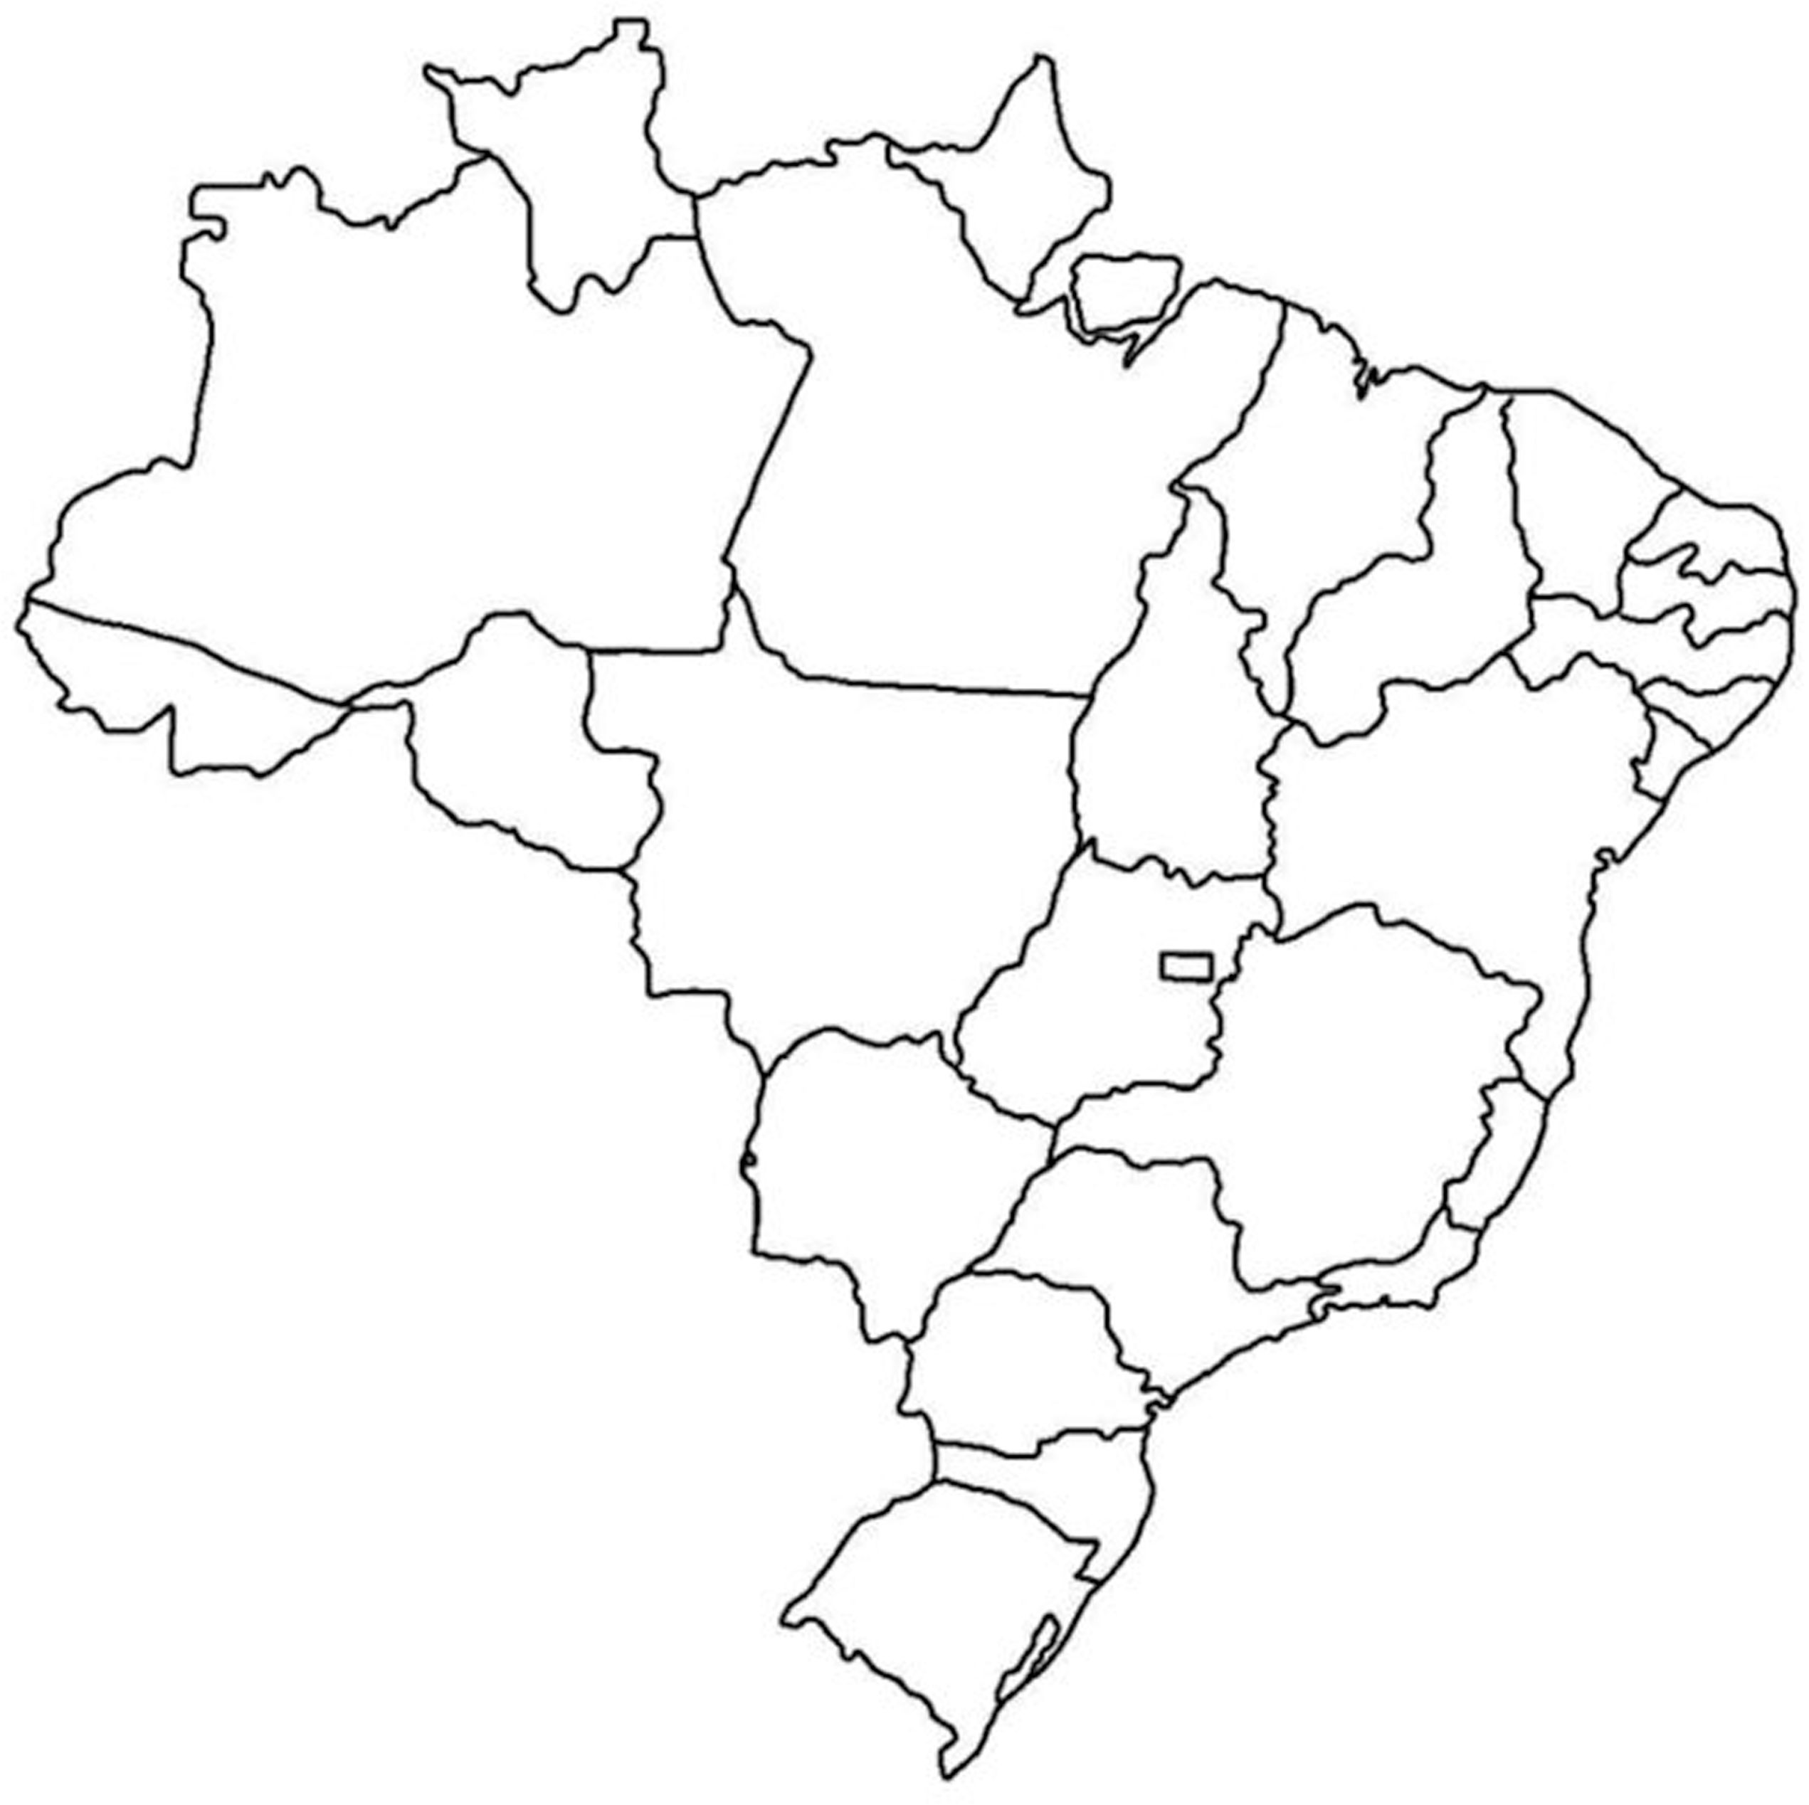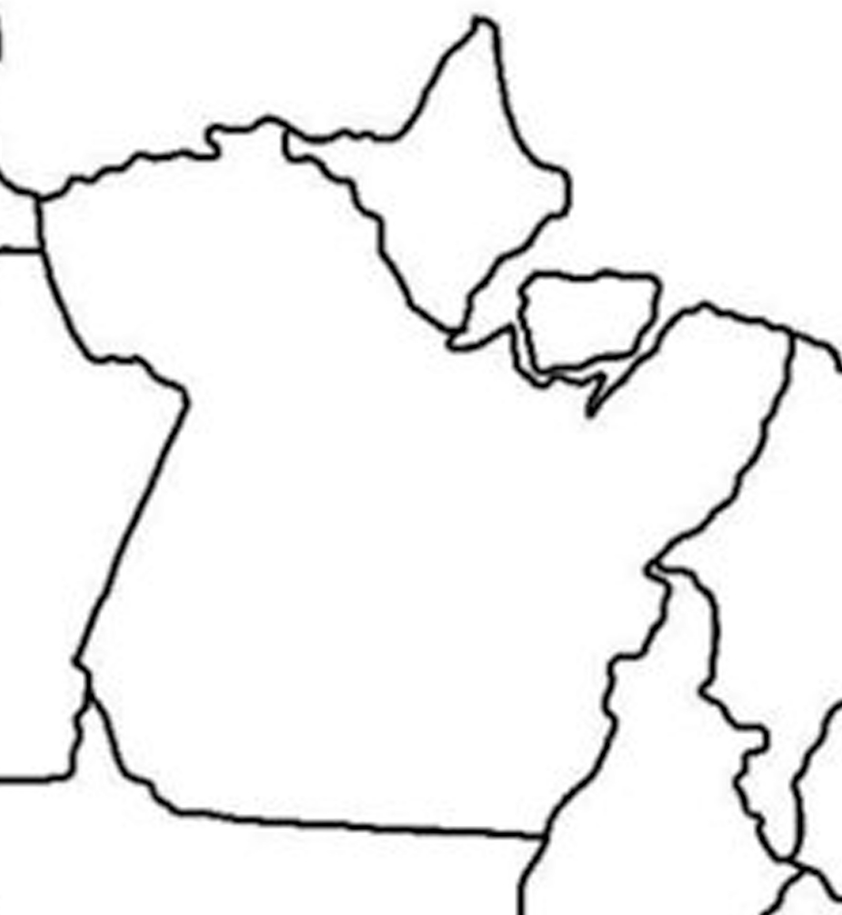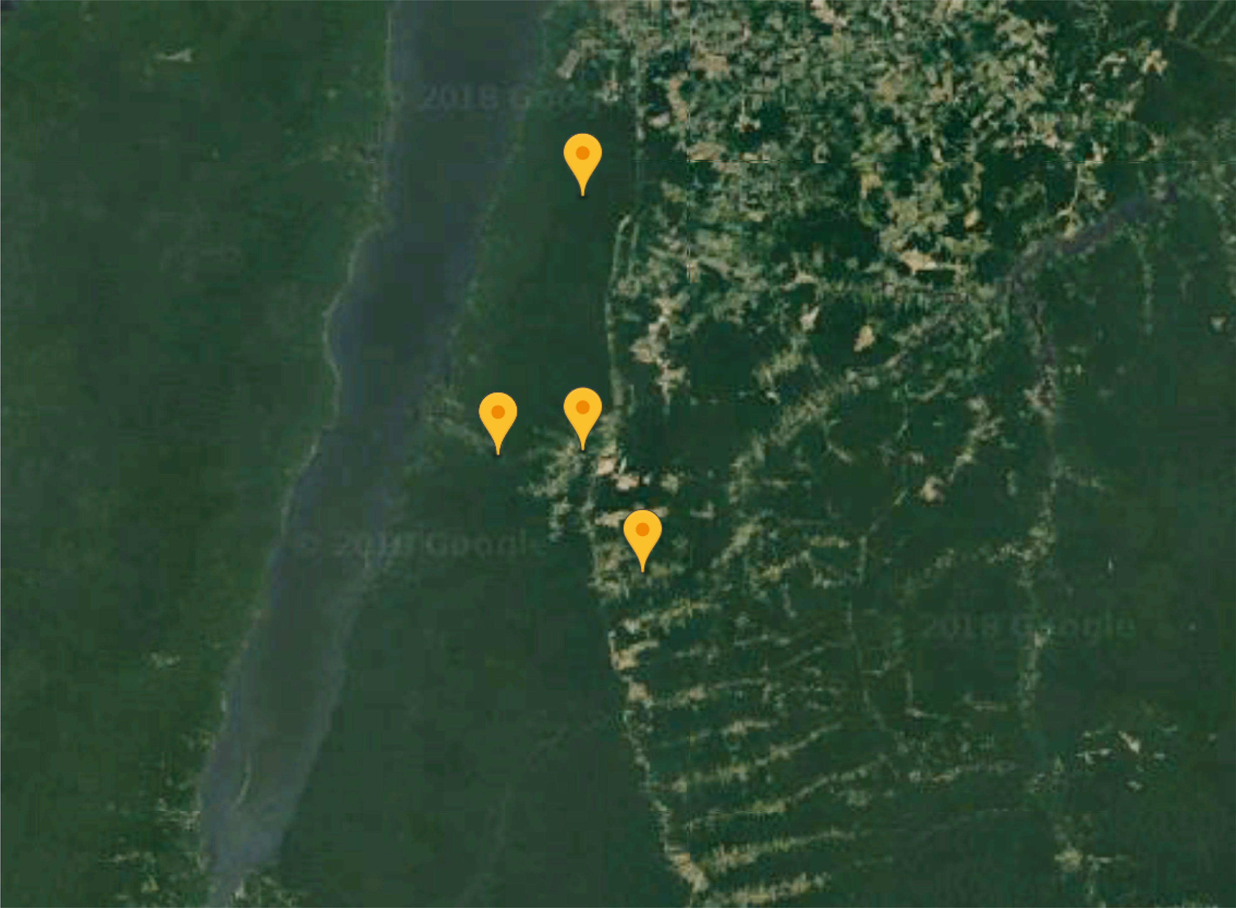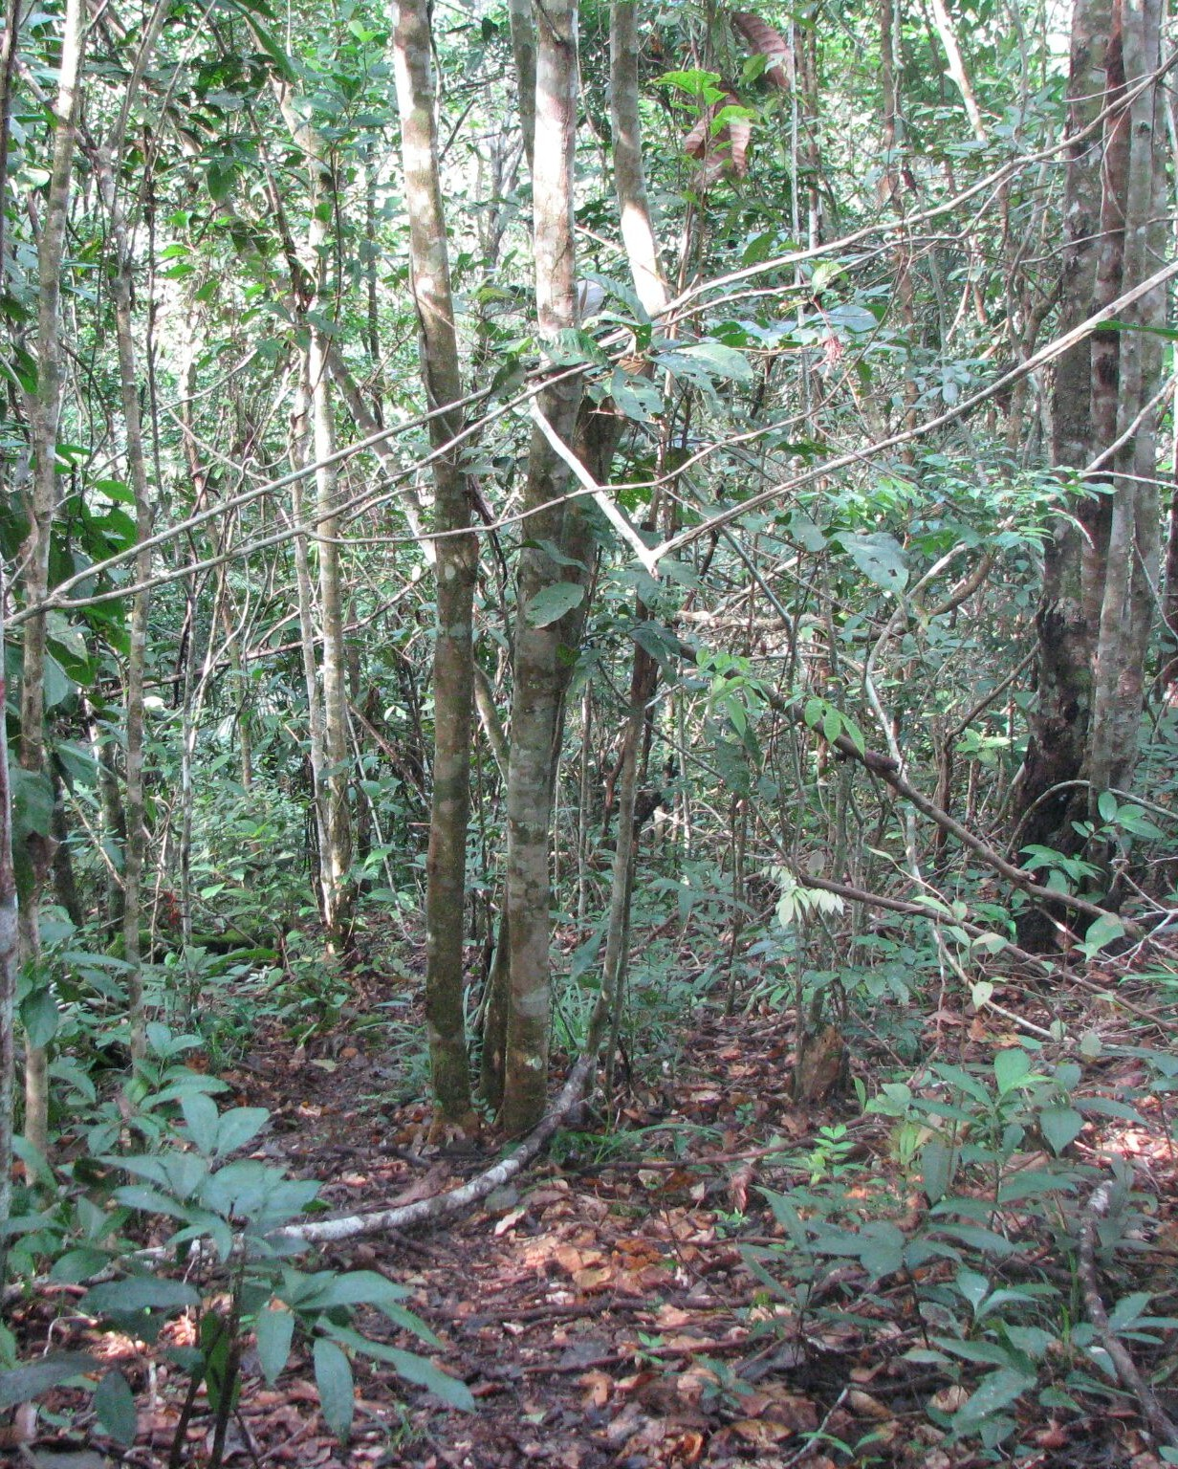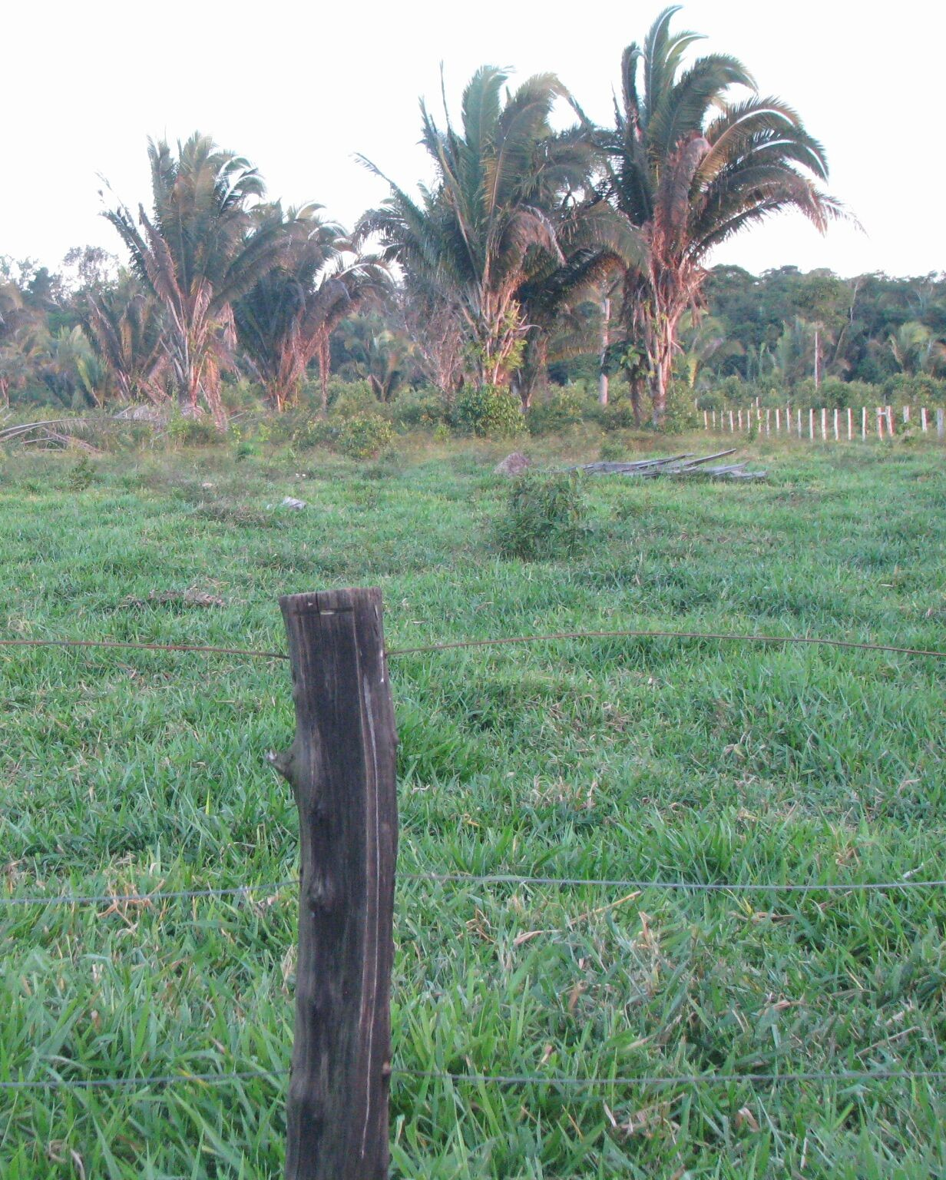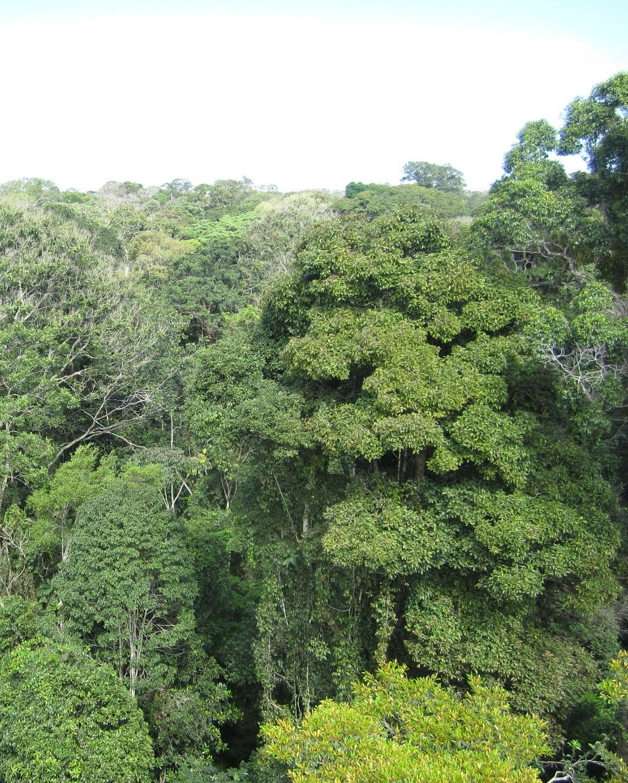

**PF**

Belterra

**PA**

**Belterra**

**SF**

Primary Forest (PF)

Pasture (PA)

Secondary Forest (SF)

**Supplementary Figure 1.** Sampling sites at Tapajós National Forest and its adjacent areas in the Belterra municipality, in the State Pará, Brazil. Yellow dots indicates the sampling points. PF = Primary Forest, PA = Pasture, SF = Secondary Forest.

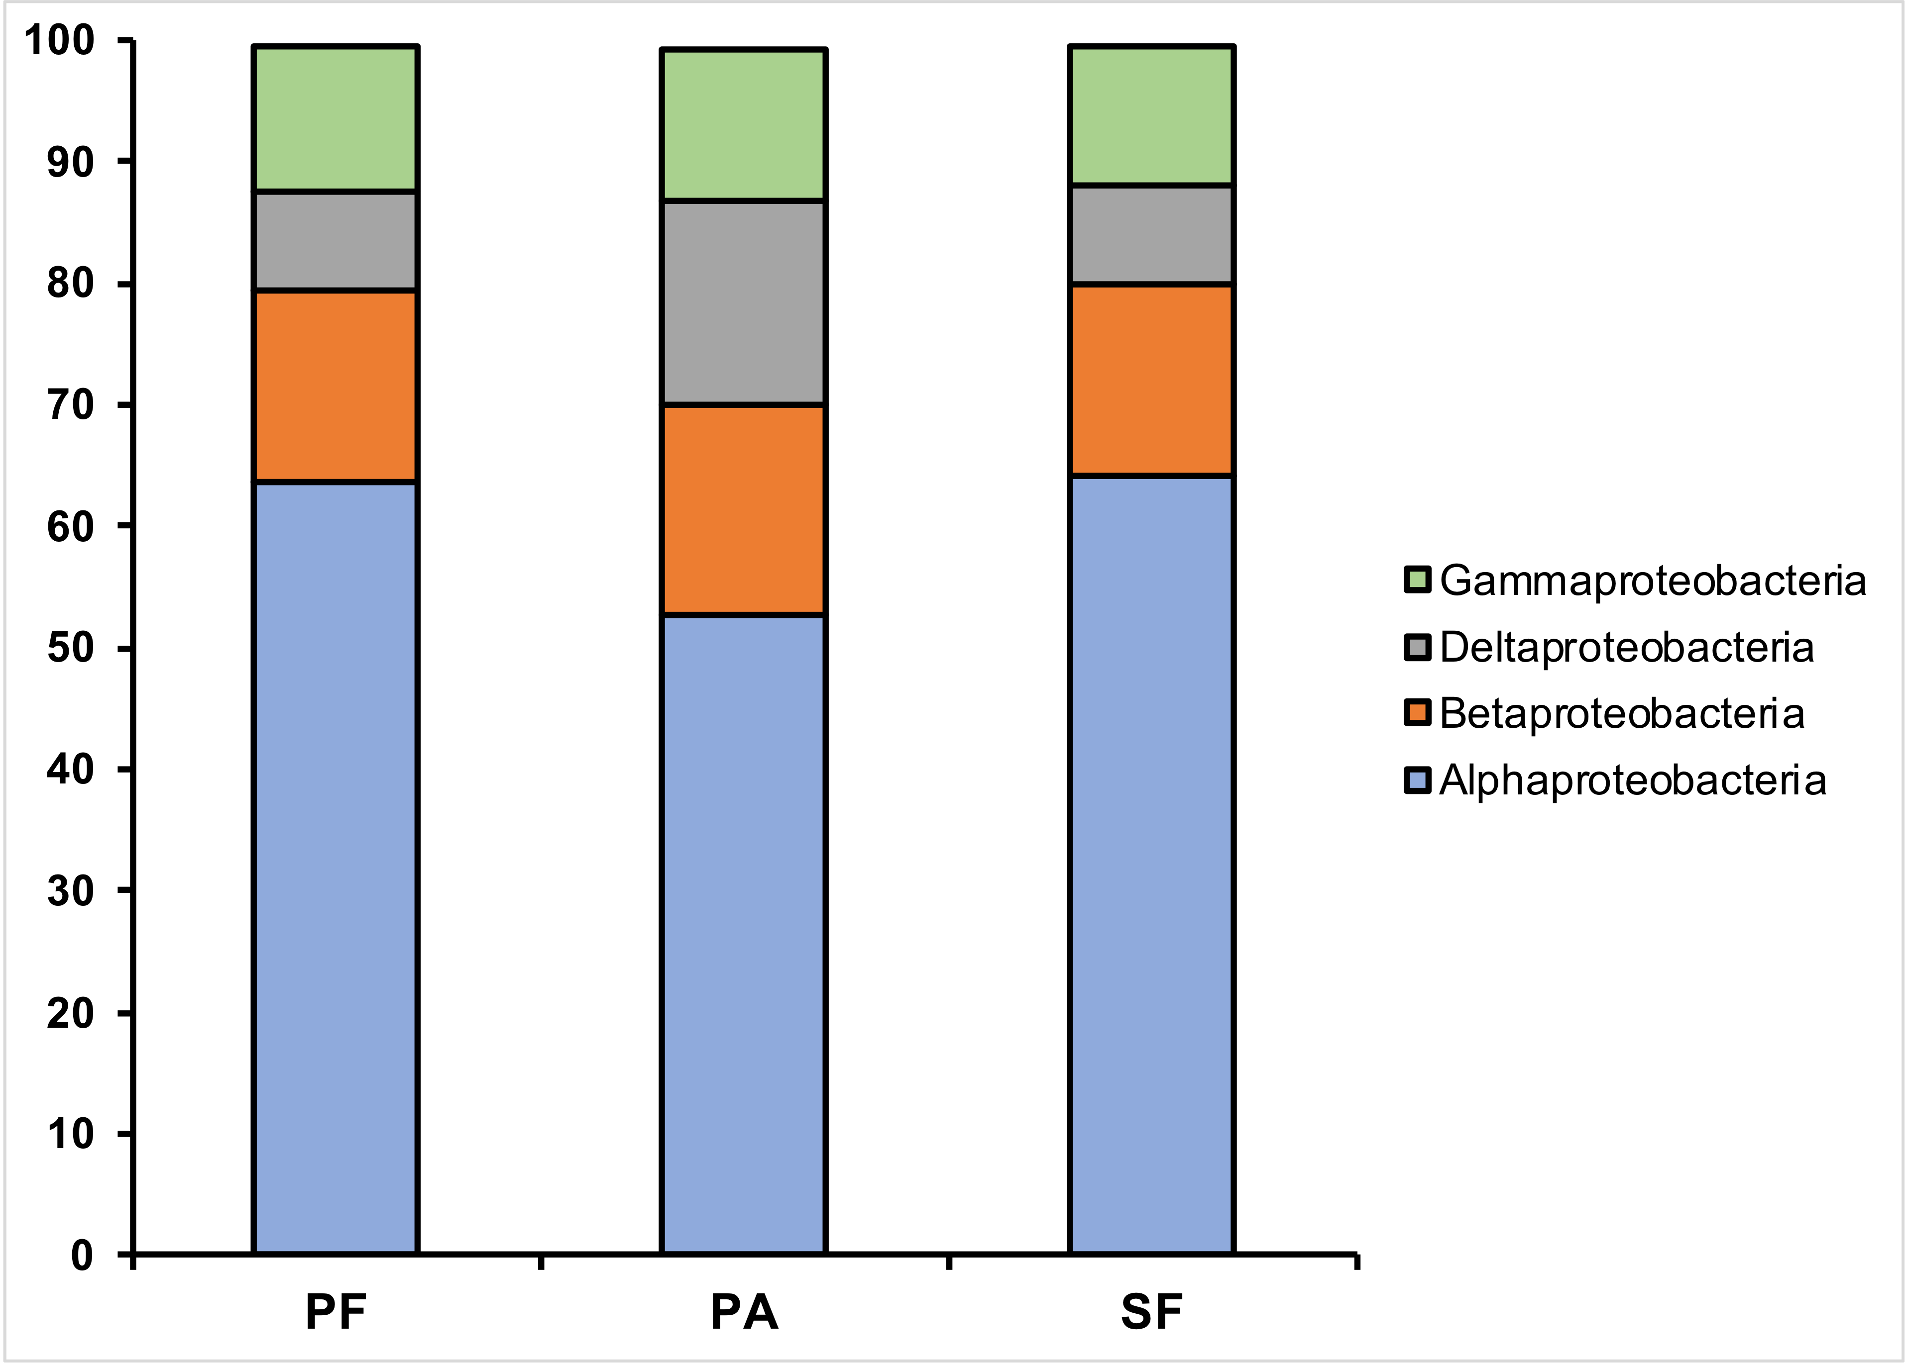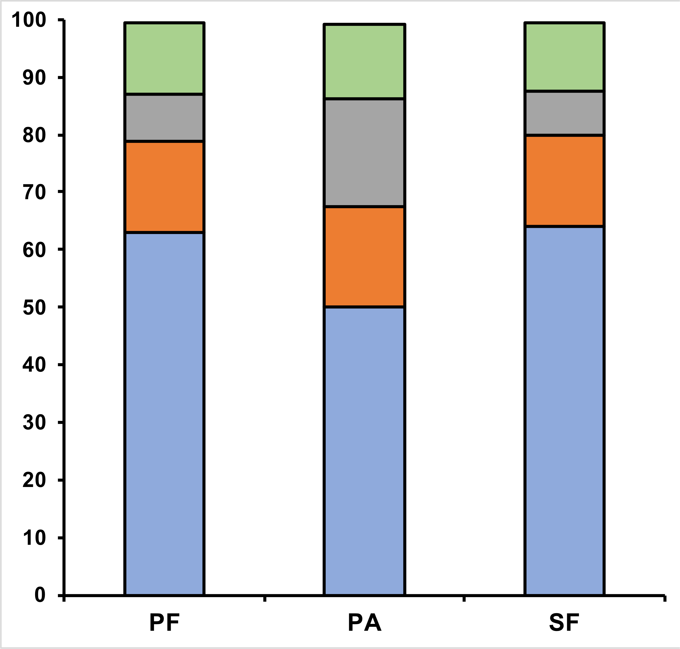

wet

dry

100

90

80

70

60

50

40

30

20

10

0

100

90

80

70

60

50

40

30

20

10

0

Gammaproteobacteria Deltaproteobacteria Betaproteobacteria

Alphaproteobacteria

PF PA SF PF PA SF

**Supplementary Figure 2.** Distribution of sequences affiliated to Proteobacteria classes for the primary forest, pasture, and secondary forest during the wet and dry seasons.

*Serratia*

*Comamonas*

Proportion of sequences (%)

Proportion of sequences (%)

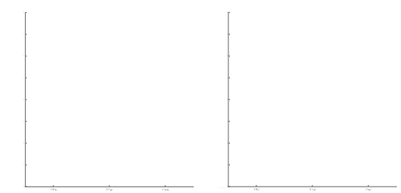

0.090

0.085

0.080

0.075

0.070

0.065

0.060

0.055

0.050

*p* = 4.34 e-4

*p* = 0.010

*Pseudomonas*

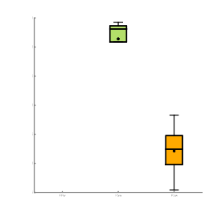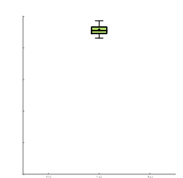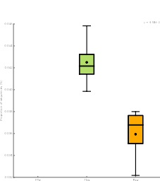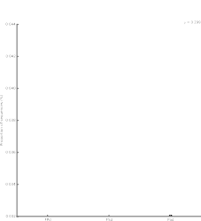

wet

dry

0.085

*p* = 1.94 e-3

*p* = 9.07 e-3

0.080

0.075

0.070

0.065

0.060

0.055

*Enterobacter*

0.046

*p* = 4.48 e-3

*p* = 0.299

0.044

0.042

0.040

0.038

0.036

0.034

0.032

Proportion of sequences (%)

Proportion of sequences (%)

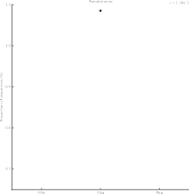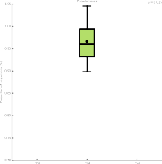

1.10

*p* = 1.39 e-3

*p* = 0.015

1.00

0.90

0.80

0.70

PF SF PA

PF SF PA

*Salmonella*

**Supplementary Figure 3.** Boxplot showing the distribution in the proportion of the genera related to sulfur metabolism in samples from (PF) primary forest, (SF) secondary forest and (PA) pasture soil in Amazon region. Boxes indicate the IQR (75th to 25th of the data). The median value is shown as a line within the box and the mean value as a star. Whiskers extend to the most extreme value within 1.5*IQR.

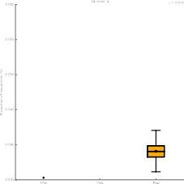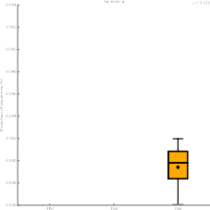

0.060

0.055

0.050

0.045

0.040

0.035

PF SF PA

PF SF PA

*p* = 0.122

*p* = 0.014

Proportion of sequences (%)